American Overseas Group Limited

Consolidated Financial Statements
For the Six Months Ended
June 30, 2026
(Unaudited)



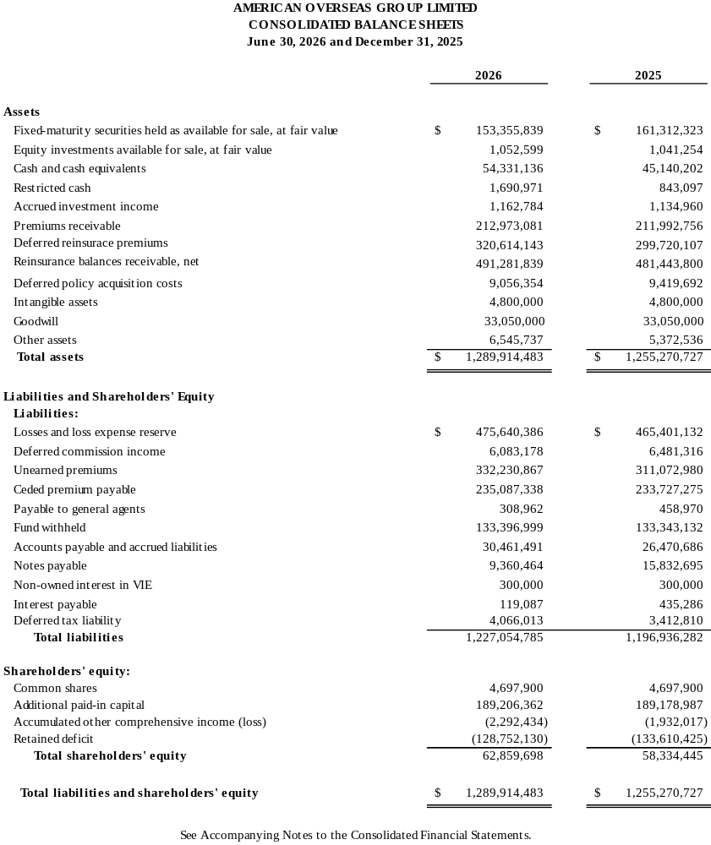

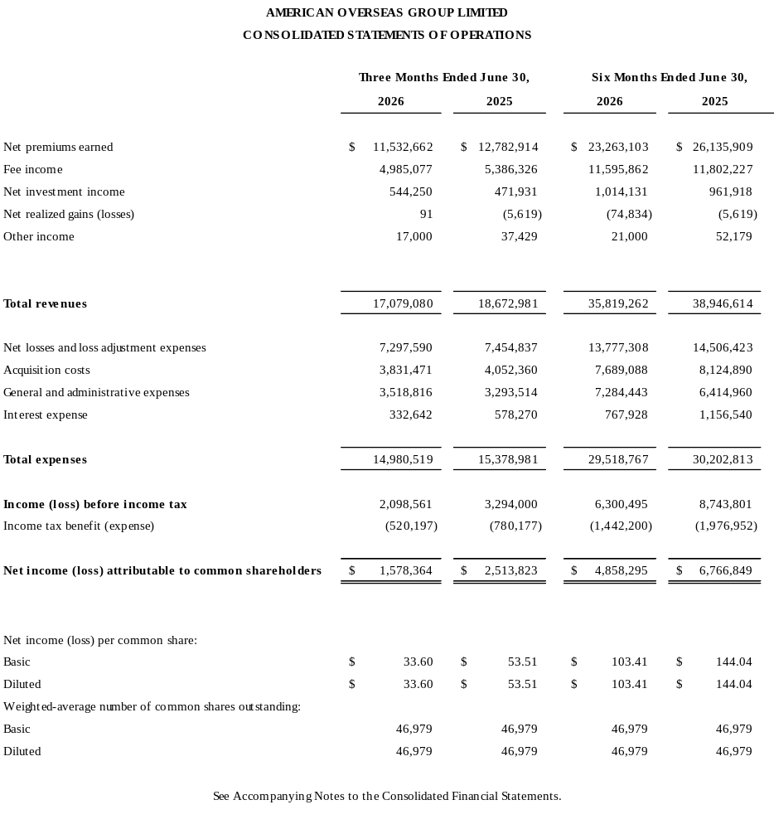

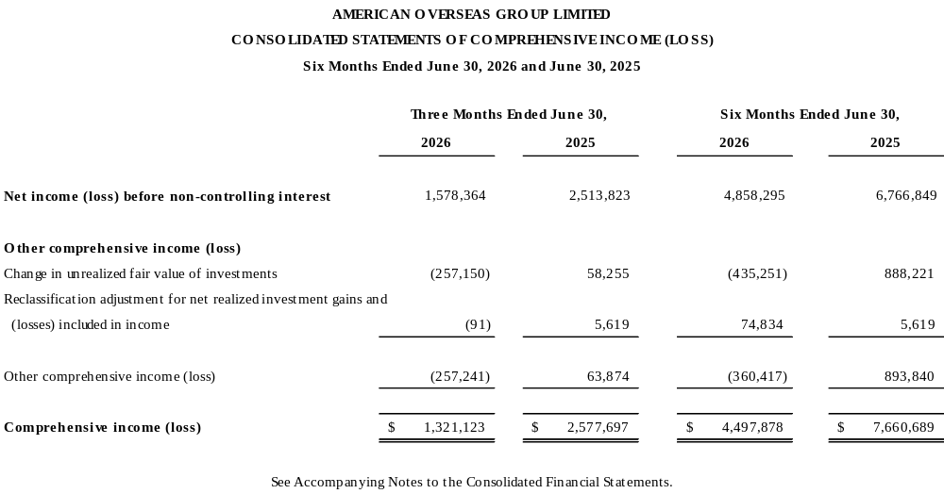

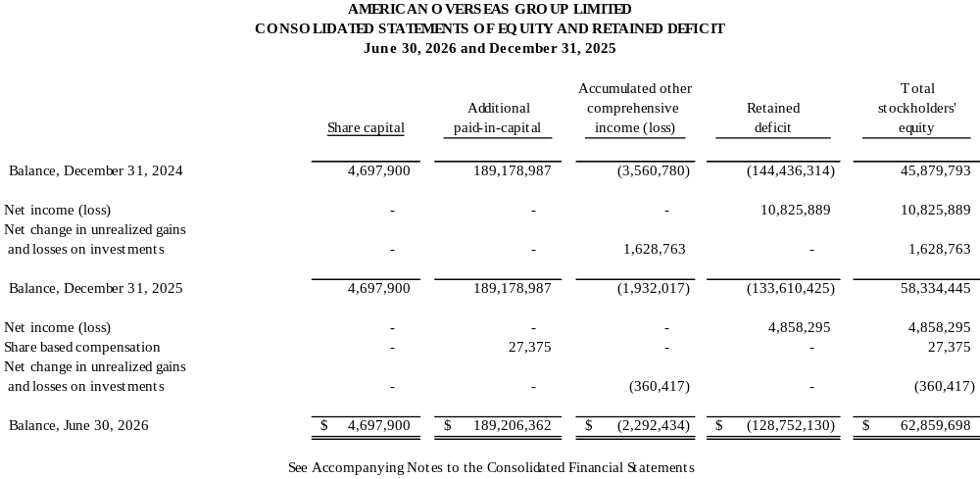

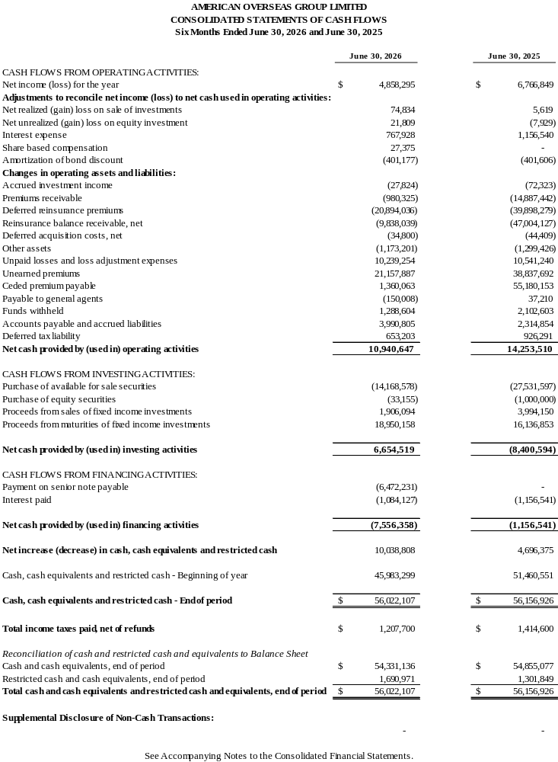

BACKGROUND

American Overseas Group Limited (“AOG” or the “Company”) was incorporated on January 28, 1998, under the laws of Bermuda. The Company was originally organized to operate a mono-line financial guaranty reinsurance subsidiary which was placed in voluntary run-off in 2009. After substantially reducing its financial guaranty exposure, AOG entered the property and casualty reinsurance business in 2012. On June 26, 2013 the Company’s principal shareholder at that time, Orpheus Group Ltd. (“OGL”), acquired voting control of AOG. On October 28, 2014, AOG acquired OGL for a combination of common stock and senior notes. The Company is now a major writer of non-standard auto insurance through its U.S. subsidiaries. All earned premium and fee income are related to its property and casualty book of business. The financial guaranty book of business was eliminated in 2020.

2. SIGNIFICANT ACCOUNTING POLICIES

The following is a summary of the significant accounting policies adopted by the Company:

- Basis of preparation

The consolidated financial statements have been prepared in accordance with accounting principles generally accepted in the United States of America (“US GAAP”). The preparation of financial statements in accordance with generally accepted accounting principles requires management to make estimates and assumptions that affect the amounts reported in the consolidated financial statements and the accompanying notes. Actual results could differ materially from those estimates.

- Basis of consolidation

The consolidated financial statements comprise the financial statements of the Company and of its subsidiaries, as well as those of Old American County Mutual Fire Insurance Company (“OACM”), a variable interest entity (“VIE”) which the Company is required to consolidate. All significant intercompany balances have been eliminated in consolidation.

- Cash and cash equivalents

The Company considers all highly liquid investments, including fixed-interest and money market fund deposits, with a maturity of 90 days or less when purchased, as cash equivalents. Cash equivalents are carried at cost which approximates fair value.

- Investments

The Company has classified its fixed-maturity and equity investments as available-for-sale. Fixed-maturity investments are carried at fair value, with unrealized appreciation or depreciation reported as a separate component of accumulated other comprehensive income. The equity investment is carried at fair value with unrealized appreciation or depreciation reported on the income statement as an unrealized gain or loss. A portion of the unrealized appreciation or depreciation related to a reinsurer is included in funds held instead of accumulated other comprehensive income as the investments are pledged and all related investment movements, primarily consisting of income and expenses inure back to the reinsurer not the Company. The Company’s fair values of fixed-maturity investments are based on prices obtained from nationally recognized independent pricing services and represent quoted prices in active markets when available. Equity securities include investments in shares of publicly traded companies and offshore mutual funds. All investment transactions are recorded on a trade date basis. Realized gains and losses on sales of fixed-maturity investments are determined on the basis of amortized cost. Gains and losses on sale of investments are included in “net realized gains(losses) on sale of investments” when realized. The cost of securities sold is determined using the specific identification method. The Company’s investment guidelines require the orderly sale of securities that do not meet investment guidelines due to a downgrade by rating agencies or other circumstances, unless otherwise authorized by management to hold.

2. SIGNIFICANT ACCOUNTING POLICIES

- Current Expected Credit Losses (CECL)

The Company and our investment services provider, Bank of Oklahoma Financial (“BOKF”), review its investment portfolio no less than quarterly in order to determine whether an unexpected credit loss exists.

Factors considered when assessing for any credit loss may include, but are not limited to: a screening process to determine if any securities held by the Company are flagged by our investment provider and a qualitative analytic review of factors such as the market position, regional economic and demographic trends, bond structure, liquidity and governance frameworks.

If an expected credit loss is determined to be needed, an allowance would be booked and adjusted as warranted by subsequent analysis.

- Guaranty fund asset

Guaranty fund assets are included in other assets on the Consolidated Balance Sheet assessed to the Company from various states when the cost of defaulted insurance companies exceed the current fund balance. Depending on when the Company receives notice of an assessment, the Company will either accrue or pay the assessment and, if allowed by the assessing state, setup a corresponding guaranty fund asset for any premium tax credits allowed. This asset is reviewed annually for collectability and will be written off, if needed.

- Revenue recognition

The Company earns property casualty insurance and reinsurance premium revenue over the terms of the related policies. Unearned premiums represent the unexpired portion of premiums written. In addition, the Company earns fee income for providing insurance capacity for its nonstandard automobile liability and physical damage insurance products produced by managing general agents or other producers and ceded to reinsurers. Fee income is the excess of the ceding commission received from the reinsurers over the commission expense paid to the managing general agents or other producers.

Premium receivables and reinsurance recoverables are evaluated for credit losses at the underwriting company level. These are evaluated based on a number of factors including, but not limited to, the current aging of the receivables, the financial monitoring of the MGA/Reinsurers, the collateral of reinsurers, and the structure of the business of the underwriting company.

- Deferred policy acquisition costs

Deferred policy acquisition costs comprise those expenses that vary with and are primarily related to the production of business, including ceding commissions paid.

When assessing the recoverability of deferred policy acquisition costs, the Company considers the future earnings of premiums and anticipated investment income and compares this to the sum of unamortized policy acquisition costs, expected loss and loss adjustment expenses and expected maintenance costs. If a deficiency were calculated, the unamortized acquisition costs would be reduced by a charge to expense. Any deficiency driven by the maintenance costs that is greater than the balance of the deferred acquisition costs for the underwriting year and risk type is recorded as a premium deficiency.

2. SIGNIFICANT ACCOUNTING POLICIES (Cont’d)

- Losses and loss adjustment expenses

Unpaid losses and loss adjustment expenses include an amount determined from individual case estimates (“case basis loss reserves”) and an amount for losses incurred but not reported. Such liabilities are necessarily based on assumptions and estimates and while management believes the amount is adequate, the ultimate liability may be in excess of or less than the amount provided. The methods for making such estimates and for establishing the resulting liabilities are continually reviewed and adjustments are reflected in the period determined.

(j) Fair value measurements

ASC 820 provides guidance for fair value measurement of assets and liabilities and associated disclosures about fair value measurement. Under this standard, the definition of fair value focuses on the price that would be received to sell the asset or paid to transfer the liability (an exit price), not the price that would be paid to acquire the asset or received to assume the liability (an entry price). ASC 820 clarifies that fair value is a market-based measurement, not an entity-specific measurement. ASC 820 establishes a fair value hierarchy of inputs in measuring fair value, with the highest level being observable inputs and the lowest being unobservable data as follows:

- Level 1 inputs – valuations based on quoted prices in active markets for identical assets or liabilities. Valuations in this level do not entail a significant degree of judgment.

- Level 2 inputs – valuations based on quoted prices for similar assets or liabilities in active markets, quoted prices for identical or similar assets or liabilities in markets that are not active and model derived valuations where all significant inputs are observable in active markets.

- Level 3 inputs – valuations based on significant inputs that are unobservable.

Disclosures relating to fair value measurements are included in Note 5 – Fair Value of Financial Instruments.

(k) Goodwill and intangible assets

The Company tests for impairment of goodwill and indefinite-lived intangible assets on an annual basis, or more frequently if events or changes in circumstances indicate that impairment exists.

The Company amortizes finite-lived intangible assets over the respective useful lives of the assets. If events or changes in circumstances indicate that impairment of these assets exists, the Company will test for impairment.
If, as a result of the evaluation, the Company determines that the value of the goodwill or intangible assets is impaired, then the value of the assets will be written down through net income in the period in which the determination of the impairment is made.

(l) Leases

At lease inception, the Company determines whether an arrangement is or contains a lease. Operating leases are included in operating lease right-of-use (“ROU”) assets, current operating lease liabilities, and noncurrent operating lease liabilities in the consolidated financial statements. ROU assets represent the Company’s right to use leased assets over the term of the lease. Lease liabilities represent the Company’s contractual obligation to make lease payments over the lease term.

For operating leases, ROU assets and lease liabilities are recognized at the commencement date. The lease liability is measured as the present value of the lease payments over the lease term. The Company uses the rate implicit in the lease if it is determinable. When the rate implicit in the lease is not determinable, the Company uses its incremental borrowing rate at the commencement date of the lease to determine the present value of the lease payments. Operating ROU assets are calculated as the present value of the remaining lease payments plus
2. SIGNIFICANT ACCOUNTING POLICIES (Cont’d)

(l) Leases (cont’d)

unamortized initial direct costs plus any prepayments less any unamortized lease incentives received. Lease terms may include renewal or extension options to the extent they are reasonably certain to be exercised. The assessment of whether renewal or extension options are reasonably certain to be exercised is made at lease commencement. Factors considered in determining whether an option is reasonably certain of exercise include, but are not limited to, the value of any leasehold improvements, the value of renewal rates compared to market rates, and the presence of factors that would cause a significant economic penalty to the Company if the option were not exercised. Lease expense is recognized on a straight-line basis over the lease term. The Company has
elected not to recognize a ROU asset and obligation for leases with an initial term of twelve months or less. The expense associated with short term leases is included in lease expense in the income statement.

To the extent a lease arrangement includes both lease and fixed non-lease components, the Company has elected to account for the components as a single lease component. To the extent the non-lease component is not fixed in nature, the non-lease components are expensed separately.

(m) Taxation

Deferred tax assets and liabilities are determined based on differences between the financial reporting and tax basis of assets and liabilities and are measured using enacted tax rates and laws that are expected to be in effect when the difference is reversed. A valuation allowance is recorded against gross deferred tax assets if it is more likely than not that all or some portion of the benefits related to the deferred tax assets will not be realized.

(n) Share-based compensation

The Company measures and records compensation costs for all share-based payment awards based on grant-date fair value over the requisite service period. This includes consideration of expected forfeitures in determining share based-based employee compensation expenses.

(o) Treasury shares

Common shares of AOG held by the Company and its subsidiaries are accounted for similar to share cancellations with the excess of the par value reflected in additional paid in capital.

(p) Recent Accounting pronouncements

New accounting pronouncements adopted:

In December 2023, the FASB issued ASC Update No. 2023-09, Income Taxes (Topic 740): Improvements to Income Tax Disclosures. This Update requires entities to disclose an annual tabular rate reconciliation, using both percentages and currency amounts, broken out into specific categories, to the extent those items exceed a specified threshold. In addition, all entities are required to disclose annual income taxes paid, net of refunds received, disaggregated by federal, state, and foreign jurisdictions, and for individual jurisdictions when the amount is at least five percent of total income tax payments, net of refunds received. This Update is effective for annual reporting periods beginning after December 15, 2024, with early adoption permitted. This guidance may be implemented either on a prospective or retrospective basis. The company adopted and implemented this ASU during 2025. See Note 15 – Taxation.

2. SIGNIFICANT ACCOUNTING POLICIES (Cont’d)

(p) Recent Accounting pronouncements (Cont’d)

Recently Issued Standards

In November 2024, the FASB issued ASC Update No. 2024-03, Income Statement - Reporting Comprehensive Income - Expense Disaggregation Disclosures (Subtopic 220-40). This Update requires entities to disclose, at each interim and annual reporting period, specified information about certain costs and expenses in the notes to financial statements. Entities must disclose the amounts, in a tabular format, of relevant expense captions presented on the face of the income statement within continuing operations that contain expenses associated with employee compensation, depreciation, and intangible asset amortization. Additionally, the Update requires qualitative disclosure of amounts remaining in relevant expense captions that are not separately disaggregated quantitatively, and the disclosure of total of selling expenses, among other items. This Update is effective for annual reporting periods beginning after December 15, 2026, and as clarified in ASC Update No. 2025-01, beginning after December 15, 2027, with early adoption permitted. This guidance may be implemented either on a prospective or retrospective basis. The Company does not expect implementation of this guidance to have a material effect on its financial position or results of operations, as the Update is disclosure related.

3. PLEDGED ASSETS

As of June 30, 2026 and December 31, 2025, there were investments of $2.2 million and $2.0 million, respectively, on deposit with state insurance department regulators related to a U.S. subsidiary.

Orpheus Re Ltd. (“ORE”) held a Section 114 Trust in favor of OACM to support obligations from the reinsurance business assumed. As of June 30, 2026 and December 31, 2025 the assets value was $16.2 million and $15.1 million, respectively.

ORE held a Section 114 Trust in favor of OAIC to support obligations from the reinsurance business assumed. As of June 30, 2026 and December 31, 2025 the assets value was $4.4 million and $4.7 million, respectively.

4. INVESTMENTS

The amortized cost, gross unrealized gains, gross unrealized losses, CECL and estimated fair value recorded in accumulated other comprehensive income of the Company’s available for sale investments at June 30, 2026 and December 31, 2025, were as follows:

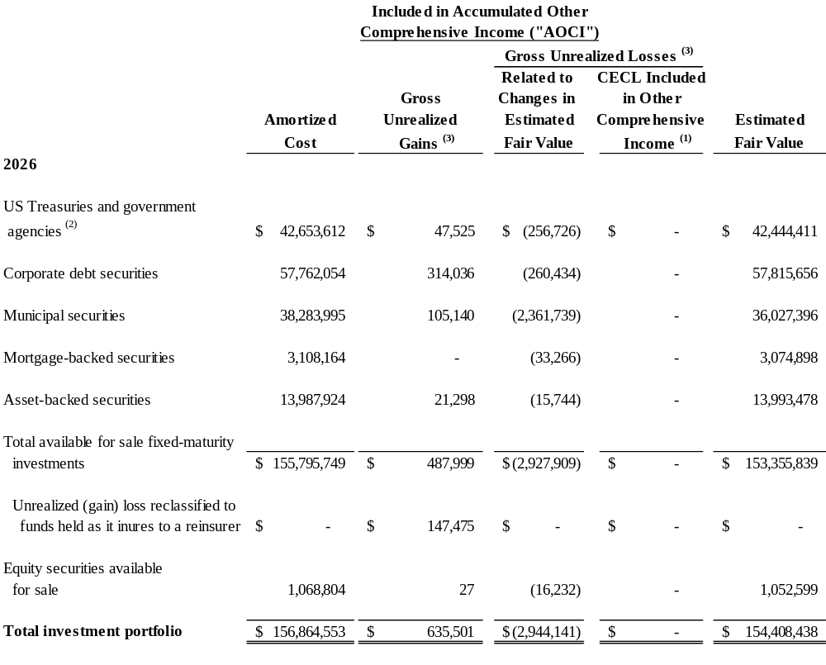

4. INVESTMENTS (cont’d)

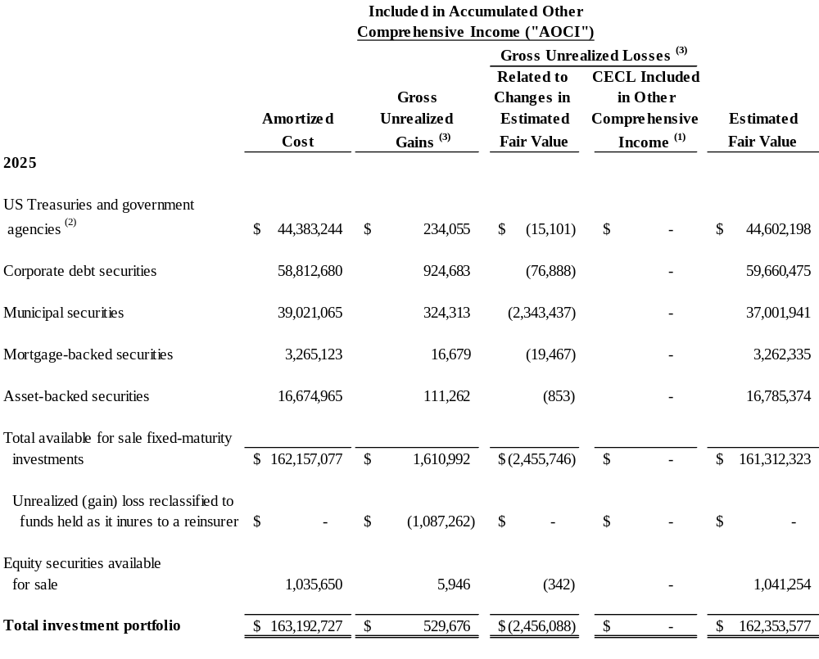

- Represents the amount of CECL losses in accumulated other comprehensive income (“AOCI”) since adoption of the accounting guidance for CECL.
- Including US Government temporary liquidity guarantee program securities.
- $0.1 million and ($1.1) million at June 30, 2026 and December 31, 2025, respectively of the unrealized appreciation or depreciation related to a reinsurer is included in funds held instead of accumulated other comprehensive income as the investments are pledged and all related investment movements, income, expenses, etc inure back to the reinsurer not the Company. This is reflected in the OACM balance included in collateral (see Note 12).

The Company did not have an aggregate investment in a single entity in excess of 10% of total investments at June 30, 2026 and December 31, 2025. The Company had no material investments in securities guaranteed by third parties and had no direct investments in financial guarantors as at June 30, 2026 and December 31, 2025.

4. INVESTMENTS (cont’d)

The amortized cost and estimated fair value of fixed-maturity securities classified as available-for–sale, as of June 30, 2026 and December 31, 2025, by contractual maturity, are shown below. Expected maturities differ from contractual maturities because borrowers may have the right to call or repay obligations with or without call or prepayment penalties.

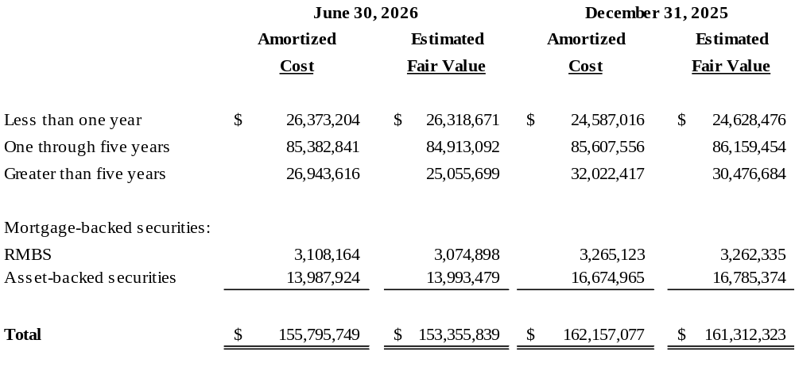
The investments that have unrealized loss positions as of June 30, 2026 and December 31, 2025, aggregated by investment category and the length of time they have been in a continuous unrealized loss position, are as follows:

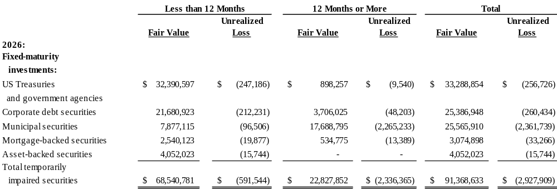
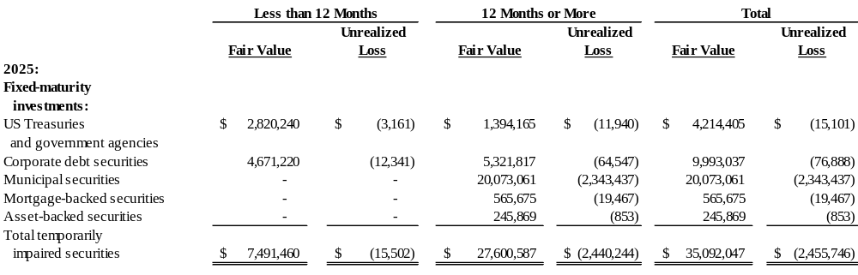
4. INVESTMENTS (cont’d)

The following table sets forth the investment ratings of the Company's available-for-sale corporate fixed income securities as at June 30, 2026 and December 31, 2025. Ratings are assigned with the lowest rating of Standard & Poor's, Moody’s, Fitch or Dominion Bond Rating Service.

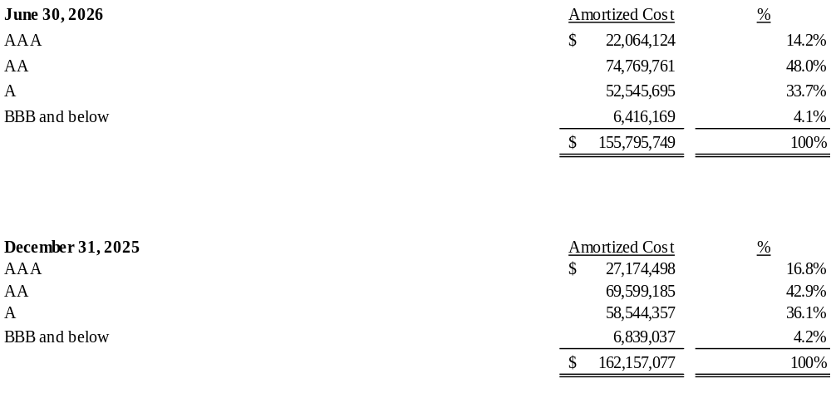

As of June 30, 2026, 186 out of 321 fixed maturity securities were in unrealized loss positions compared to 99 out of 338 as of December 31, 2025. As at June 30, 2026, the Company’s unrealized loss position for fixed maturity securities was $2.9 million compared to $2.5 million at December 31, 2025. None of securities in an unrealized loss position was related to securities below investment grade or not rated. Unrealized gains and losses relating to fixed maturity investments, excluding any credit loss portion, are currently recorded in accumulated other comprehensive income in shareholders’ equity as the Company does not intend to sell the securities in an unrealized loss position and it is more likely than not that the Company will not be required to sell these securities before the anticipated recovery of their amortized costs. Sixty-one of the securities have been in an unrealized loss position for 12 months or more as of June 30, 2026 and there were eighty-five securities in an unrealized loss position for 12 months or more as of December 31, 2025.

Proceeds from maturities and sales of investments in fixed-maturity securities available for sale during the six months ended June 30, 2026 and year ended December 31, 2025 were $20.9 million and $52.1 million, respectively. Gross gains of $11,330 and $14,307 in the six months ended June 30, 2026 and year ended December 31, 2025, respectively, and gross losses of $86,164 and $122,704 in the six months ended June 30, 2026 and year ended December 31, 2025, respectively, were realized on those sales.

4. INVESTMENTS (cont’d)

Major categories of net investment income (expense) are summarized as follows:

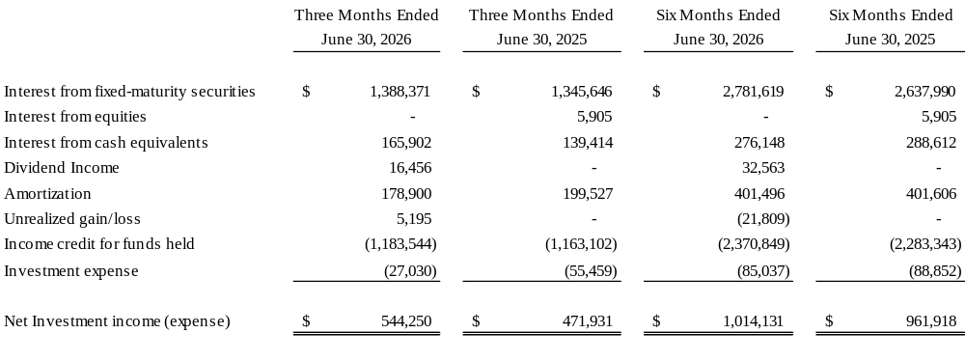

5. FAIR VALUE OF FINANCIAL INSTRUMENTS

Fair value measurements

The Company follows the guidance of ASC 820 for fair value measurement of financial instruments. ASC 820 establishes a hierarchy of inputs in measuring fair value, with the highest level being observable inputs and the lowest being unobservable data, with the standard requiring that the use of observable inputs is maximized (see Note 2(i) - Significant Accounting Policies – Fair Value Measurements for a description of each of the three levels).

The following table presents the fair value measurement levels for assets and liabilities, which the Company has recorded at fair value as of June 30, 2026 and December 31, 2025. As required by ASC 820, items are classified in their entirety based on the lowest level of input that is significant to the fair value measurement:

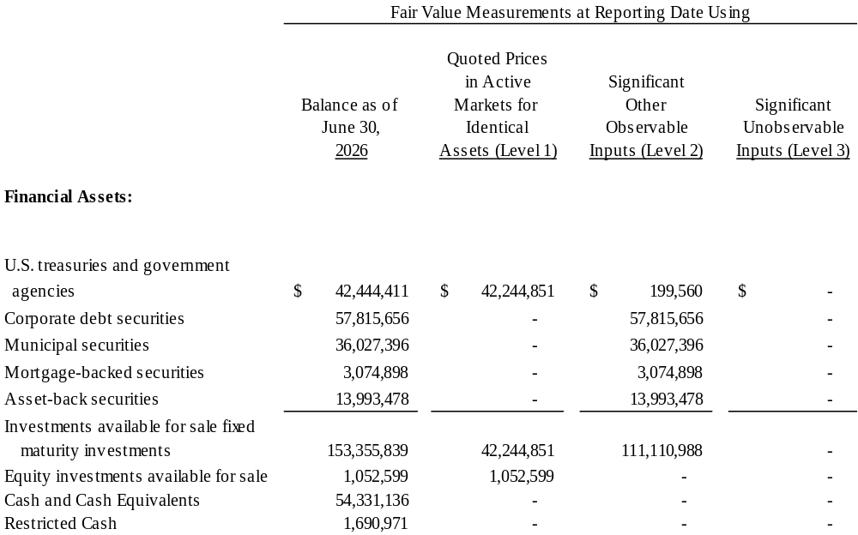

5. FAIR VALUE OF FINANCIAL INSTRUMENTS (cont’d)

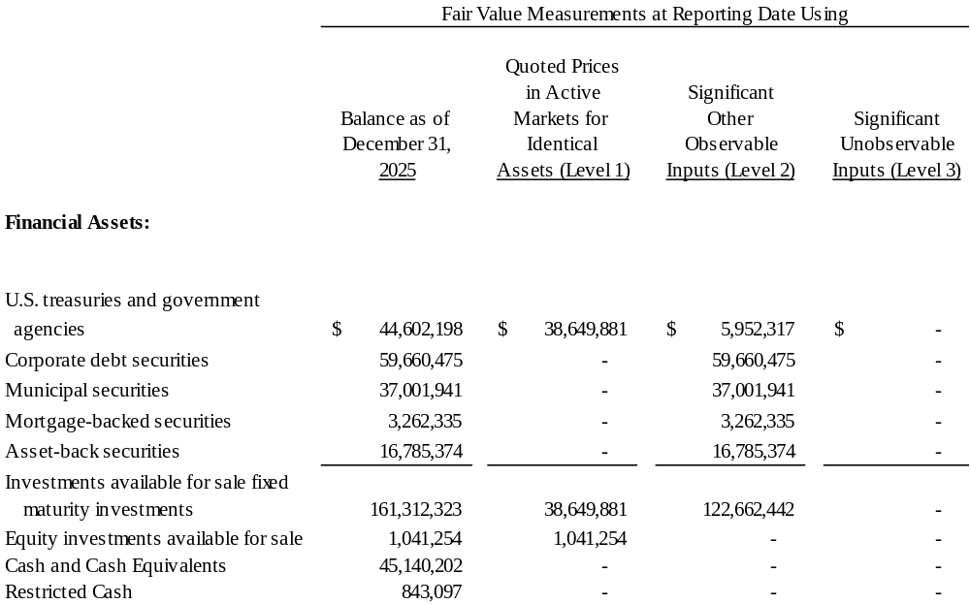

Fixed-maturity investments

The Company’s fair values of fixed-maturity and short-term investments are based on prices obtained from nationally recognized independent pricing services. Where available, the prices are obtained from market quotations in active markets. Where there is no quoted price for an identical security, then the pricing service may use matrix pricing or model processes, such as the option adjusted spread model, to estimate the fair value of a security. The matrix pricing or model processes consist primarily of observable inputs, which may include: benchmark yields, reported trades, broker/dealer quotes, issuer spreads, two-sided markets, benchmark securities, bids, offers and reference data. The Company receives at least one fair value price for each of its investment securities and has not adjusted any of the prices received from the pricing services. At June 30, 2026 and December 31, 2025, all the Company’s securities were valued using the independent pricing services.

As management is ultimately responsible for determining the fair value measurements for all securities, the Company assesses the reasonableness of the fair values received by comparing them to other pricing information readily available and management’s knowledge of the current markets. The Company also assesses the pricing methodologies and related inputs used by the pricing services to estimate fair value. Any prices that, in management’s opinion, may not be representative of fair value are challenged with the pricing service. Based on the information obtained from the above reviews, the Company evaluated the fixed-maturity securities in the investment portfolio to determine the appropriate fair value hierarchy level in accordance with ASC 820. Based on the Company’s evaluation, each security was classified as Level 1, 2, or 3. Prices with observable market inputs, money market funds and US treasuries were classified as Level 2. There were no market inputs classified as Level 3 as of June 30, 2026 and December 31, 2025.

5. FAIR VALUE OF FINANCIAL INSTRUMENTS (cont’d)

Equity investments

The Company’s equity investments are comprised of funds invested in a range of diversified strategies. In accordance with U.S. GAAP, the fair values of the funds are based on the unadjusted net asset value of the funds and as such, the Company has adopted NAV as a practical expedient and this is not presented in the levelling table. The Company validates these prices through agreeing net asset values to audited financial statements where available, in conjunction with regular discussion and analysis of the investment portfolio’s structure.

Other fair value disclosures

Management has estimated the fair value of certain financial instruments based upon market information using appropriate valuation methodologies. Fair value estimates are not necessarily indicative of the amount the Company could realize in a current market exchange.

The Company considers carrying amounts of cash and cash equivalents, interest, other assets, accounts payable and accrued liabilities to be reasonable estimates of their fair values.

Carrying value of all financial assets and liabilities is equivalent to fair value.

6. CURRENT EXPECTED CREDIT LOSSES

As of June 30, 2026 and December 31, 2025, it was determined there were no expected credit losses related to investments, premium receivables, or reinsurance recoverables.

7. LOSSES AND LOSS EXPENSE RESERVE

The Company’s loss and loss expense reserve as of June 30, 2026, represented case basis loss reserves and incurred but not reported reserves. Refer to Note 2 - Significant Accounting Policies for a description of the Company’s accounting policy for insurance losses.

A summary of the movement in the provision for losses and LAE for the six months ended June 30, 2026 and year ended December 31, 2025 is presented in the following table:
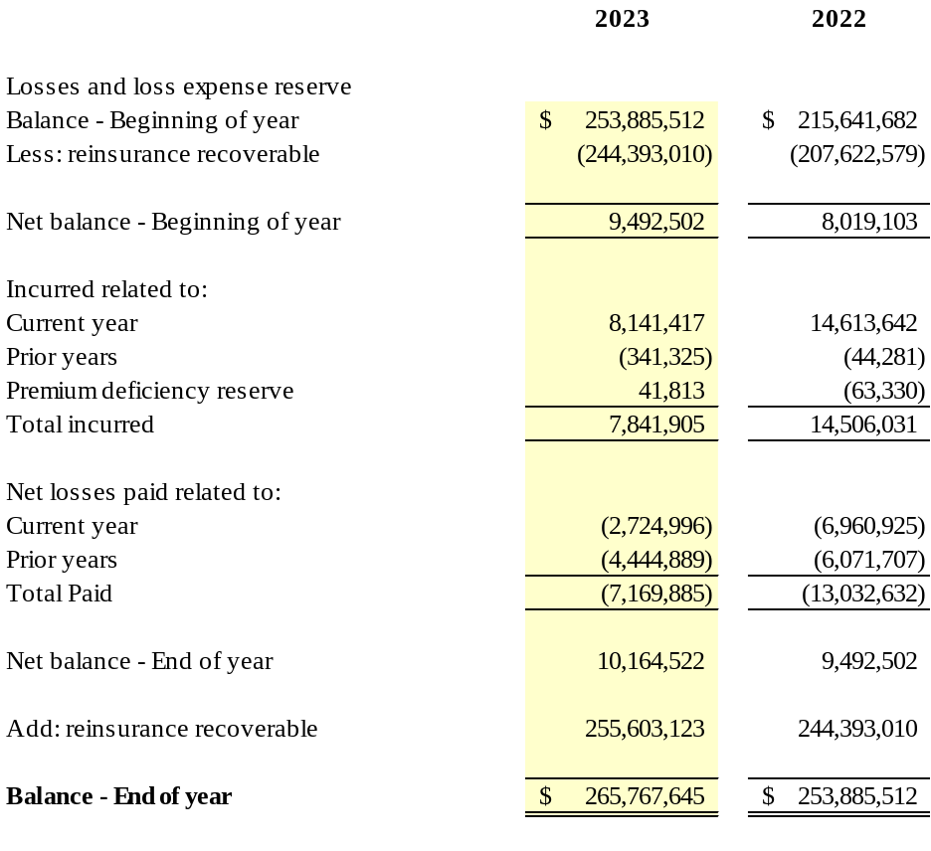
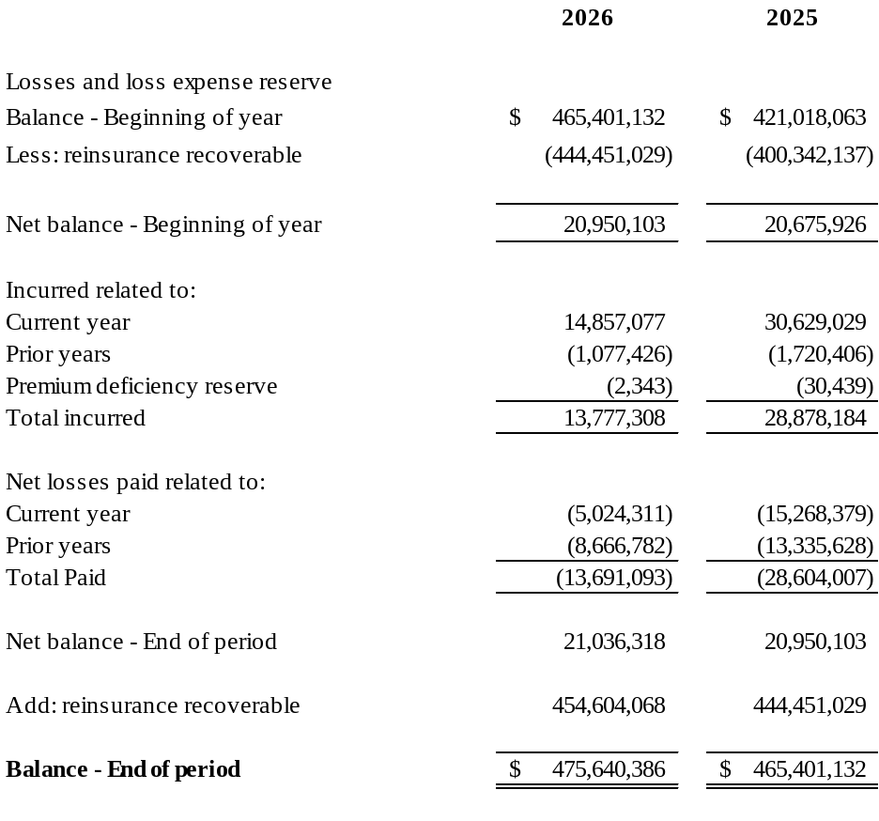
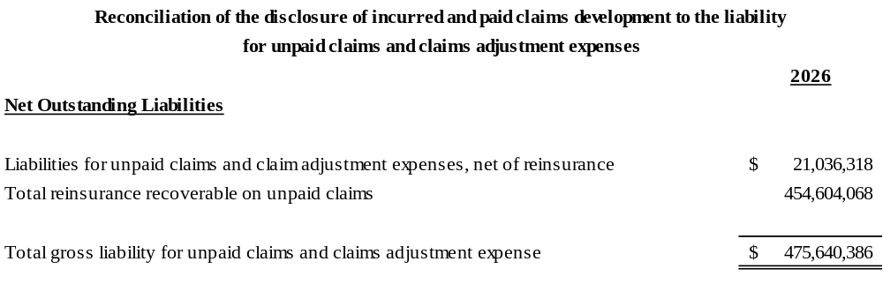

8. SEGMENT INFORMATION

The determination of reportable segments is based on how management monitors the Company’s underwriting operations. Management monitors the performance of its underwriting operations based on the markets and customers served and the type of accounts written. The Company is currently organized into two operating segments: property/casualty insurance/reinsurance and corporate/other. All product lines fall within these classifications. The property/casualty segment provides insurance and reinsurance related to US short-tail personal lines.

The separate financial information is presented consistent with the way results are regularly evaluated by the Company’s Chief financial officer, in his role as chief operating decision maker (“CODM”) in deciding how to allocate resources and in assessing performance. Results of the reporting segments are evaluated based on operating income (loss) before interest expense and income taxes, which excludes certain items that are included in net income, such as net realized and unrealized investment gains and losses. Such gains and losses are excluded since they are determined by interest rates, financial markets and the timing of sales. Also, operating income (loss) before interest expense and income taxes excludes net gains and losses on disposals of businesses, gains and losses related to the repayment of debt, discontinued operations, costs to acquire businesses, restructuring costs, the cumulative effect of accounting changes and certain other items. Although the items excluded from operating income (loss) before interest expense and income taxes may be important components in understanding and assessing the Company’s overall financial performance, management believes that the presentation of operating income (loss) before interest expense and income taxes enhances an investor’s understanding of the Company’s results of operations by highlighting net income attributable to the core operations of the business. However, operating income (loss) before interest expense and income taxes should not be construed as a substitute for income before income taxes or income from continuing operations or as a substitute for net income.

The following tables provide a summary of the segment results.

8. SEGMENT INFORMATION (cont’d)

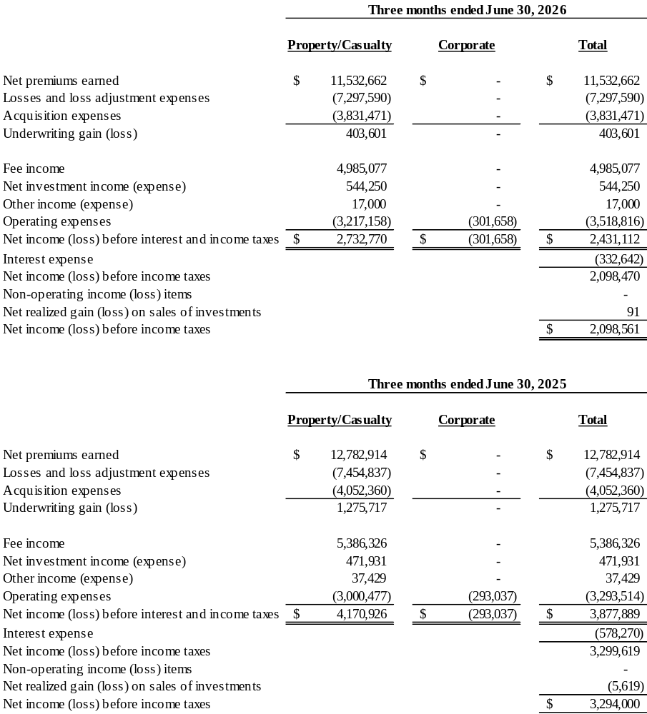

8. SEGMENT INFORMATION (cont’d)

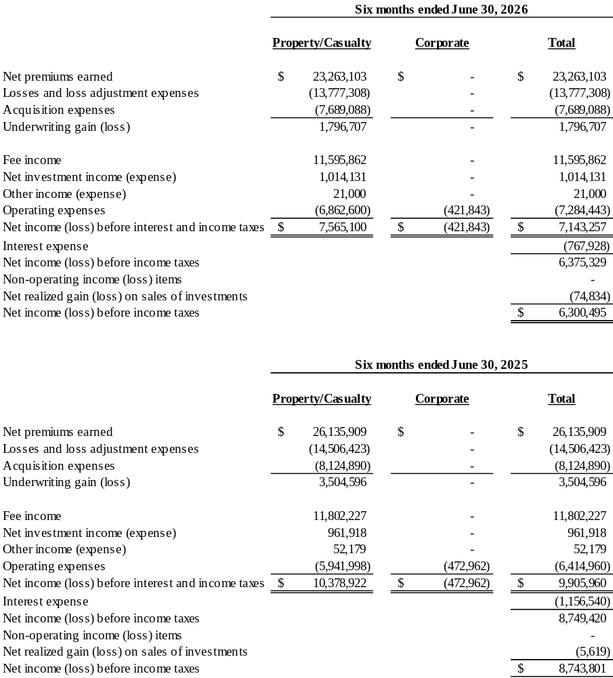

9. COMMITMENTS AND CONTINGENCIES

The insurance and reinsurance subsidiaries of the Company are involved in various claims and legal actions arising in the ordinary course of business. Some claims allege breach of good faith and fair dealing; however, those entities are vigorously defending their position, and in the opinion of management, the ultimate outcome of these matters will not have a material adverse effect on the Company’s financial position, results of operations or cashflows.

10. LEASES

The Company has 3 operating leases comprised of two vehicles and office space. The vehicles have remaining lease terms of 0.92 and 1.42 years with fixed lease payments. The Company renegotiated a lease extension on the office space on September 10, 2025 to extend the original lease to January 31, 2034 which results in a remaining lease term of 7.58 years, including a lease schedule reflecting increases each year and includes renewal options up to 10 years.

The components of lease expense were as follows:

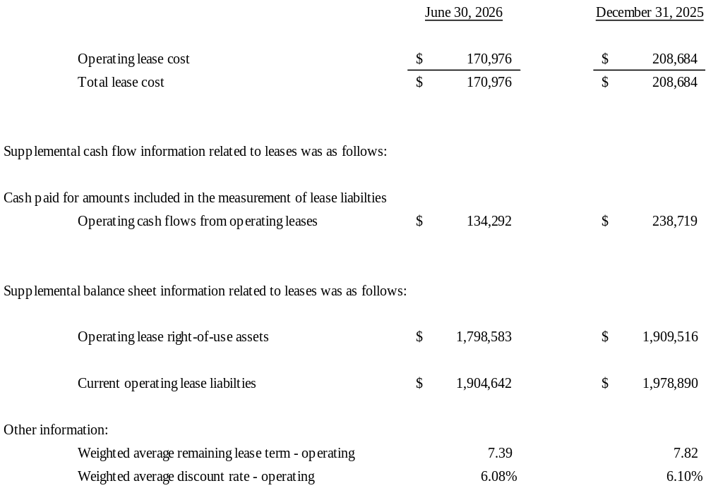

10. LEASES (cont’d)

Future minimum lease payments as of June 30, 2026 are as follows:

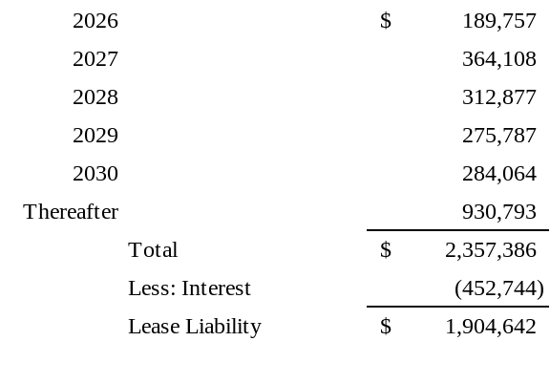
As of June 30, 2026, the Company has no additional operating leases that have not yet commenced.

11. EARNINGS (LOSS) PER SHARE

Basic earnings (loss) per share is computed by dividing net income (loss) available to common shareholders by the weighted average number of common shares outstanding during the period. Diluted earnings (loss) per share shows the dilutive effect of all stock options and restricted share units outstanding during the period that could potentially result in the issuance of common shares. The calculation of diluted earnings (loss) per share excludes the dilutive effect of stock options and restricted share awards outstanding because it would otherwise have an anti-dilutive effect on net earnings (loss) per share. The weighted average number of common and common share equivalents outstanding is calculated using the treasury stock method for all potentially dilutive securities.

As of June 30, 2026 and December 31, 2025, there were nil and 325, respectively, of stock options excluded from the diluted earnings (loss) per share calculation because they were anti-dilutive.

The table sets forth the computation of basic and diluted earnings per share for following:

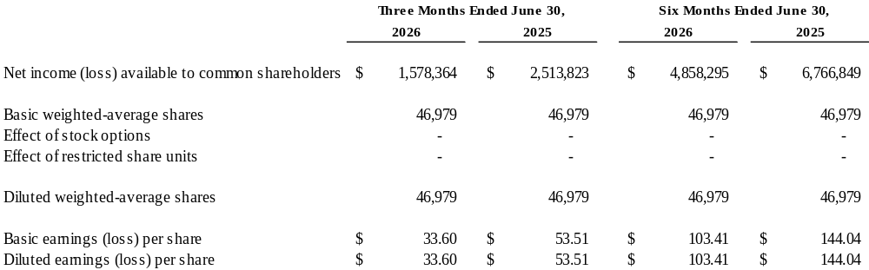

12. RISKS AND UNCERTAINTIES

The Company evaluates its financial condition and capital adequacy on an ongoing basis and may pursue a different set of strategies in the future. There can be no assurance that the strategies that have been implemented or that will be pursued in the future in connection with this evaluation will improve the Company’s business, financial condition, liquidity or results of operations or will not have a material adverse effect on the Company. Management believes that the Company has sufficient capital resources and liquidity to meet its obligations and therefore that the Company remains a “going concern.”

AOG is a holding company and therefore its liquidity, both on a short-term basis (for the next twelve months) and a long-term basis (beyond the twelve months), is largely dependent upon (1) the ability of its subsidiaries to pay dividends or make other payments to AOG and (2) its ability to access debt and equity markets. AOG’s principal uses of liquidity are for payment of operating expenses, and capital investments in its subsidiaries. As of June 30, 2026, AOG has $0.1 million of cash and investments and believes that it will have sufficient liquidity to meet its requirements over at least the next twelve months. The subsidiaries’ ability to declare and pay dividends to AOG may be influenced by a variety of factors such as adverse loss development, amount and timing of claims payments, adverse market changes, insurance regulatory changes, changes in general economic conditions beyond the next twelve months and Barbados law. The Company believes that AOG’s expected liquidity needs can be funded from its operating subsidiaries for the next twelve months and beyond.

AOG’s property/casualty segment generates substantial cash flows from its fee-based model. The principal uses of liquidity for those entities are the payment of operating expenses, debt service on subsidiary notes and capital investment in property/casualty subsidiaries. The property/casualty subsidiaries are highly leveraged through their reinsurance arrangements, and disputes with reinsurers could severely impact the liquidity of these subsidiaries. The property/casualty subsidiaries attempt to mitigate this exposure by holding collateral from their reinsurers. At June 30, 2026, the subsidiaries held $316.3 million of collateral compared to $295.9 million of balances at December 31, 2025 and such amounts are included in reinsurance balances received net on the consolidated balance sheet.

At June 30, 2026, the Company had $210.4 million of cash and investments of which approximately $176.9 million was held in trust for the benefit of our ceding companies and others, leaving $33.5 million cash and investments available to support ongoing business. See Note 3 – Pledged Assets, for further information regarding these trust accounts.

13. GOODWILL AND INTANGIBLE ASSETS

The Company performs its impairment analysis of goodwill and indefinite-lived intangible assets annually as of December 31. As of June 30, 2026, there have been no changes to the information disclosed in the 2025 annual report.

14. NOTES PAYABLE
In 2015, a series of new Series A Secured Senior Notes (the “2015 OACC Notes”) were issued and superseded previously issued notes. The 2015 OACC notes will mature on January 1, 2040 and pay interest in quarterly installments at a fixed rate of 12.0% per annum. Principal repayments of $6.5 million and $4.3 million were made in 2026 and 2025, respectively, on the 2015 OACC Notes. As of June 30, 2026, nil in interest was accrued and unpaid on the $4.1 million remaining balance of the 2015 OACC Notes.
In connection with the acquisition of OGL, AOG issued $43.9 million of Senior Notes (the “AOG Notes”) to the former shareholders of OGL that mature on October 28, 2039. During 2021, the AOG notes were transferred to OACC (now the “2021 OACC Notes”) as a dividend in kind. The terms on the 2021 OACC Notes remain the same. Interest on the 2021 OACC Notes is payable in quarterly installments at a fixed rate of 9.0% per annum. Principal repayments of nil and $0.7 million were made in 2026 and 2025, respectively, on the 2021 OACC Notes. As of June 30, 2026, $0.1 million in interest was accrued and unpaid on the remaining balance of $5.3 million on the 2021 OACC Notes.

14. NOTES PAYABLE (cont’d)
Directors and family members of AOG and its subsidiaries held notes payable in the aggregate principal amount of approximately $4.9 million and $8.7 million at June 30, 2026 and December 31, 2025, respectively.

15. TAXATION

The Company has received an undertaking from the Bermuda government exempting it from all local income, withholding and capital gains taxes until March 31, 2035. At the present time, no such taxes are levied in Bermuda.

In September 2014, AOG became tax resident in the U.K., although remains a Bermuda-based company. The Bermuda Corporate Income Tax Act 2023 (“Bermuda Act”) was enacted on December 27, 2023 and became effective January 1, 2025. The Company is not within the scope of the legislation as our group revenue is less than 750 million Euro and therefore will not be subject to tax under the Bermuda Act. As the company is not incorporated in the U.K., it intends to manage its affairs in such a way as to establish and maintain status as tax resident in the U.K. As an U.K. tax resident company, AOG is required to file a corporation tax return with His Majesty’s Revenue & Customs (“HMRC”). AOG is subject to U.K. corporation tax in respect of its worldwide profits (both income and capital gains), subject to any applicable exemptions. The main rate of corporation tax is 25%. The Company does not expect that AOG’s being a U.K. tax resident will result in any material change in the group’s overall tax charge. The Company expects that the dividends received by AOG from its direct subsidiaries will be exempt from U.K. corporation tax due to the exemption in section 931D of the U.K. Corporation Tax Act 2009. In addition, any dividends paid by AOG to its shareholders should not be subject to any withholding tax in the U.K. The U.K. government implemented a new tax regime for “controlled foreign companies” (“CFC regime”) effective January 1, 2013. The Company does not expect any profits of non-U.K. resident members of the group to be taxed under the CFC regime.

ORE has made an election under Section 953(d) of the U.S. Internal Revenue Code and is therefore treated as a U.S. domestic insurance company for U.S. federal income tax purposes. As a result, ORE is subject to U.S. federal income tax on its worldwide income. All subsidiaries that are includable in the U.S. consolidated tax group file a consolidated U.S. federal income tax return with Old American Capital Corporation as the common parent.

15. TAXATION (cont’d)

The following is a summary of the Company’s income before income tax (expense) benefit by regulatory jurisdiction for the three and six months ended June 30, 2026 and 2025:

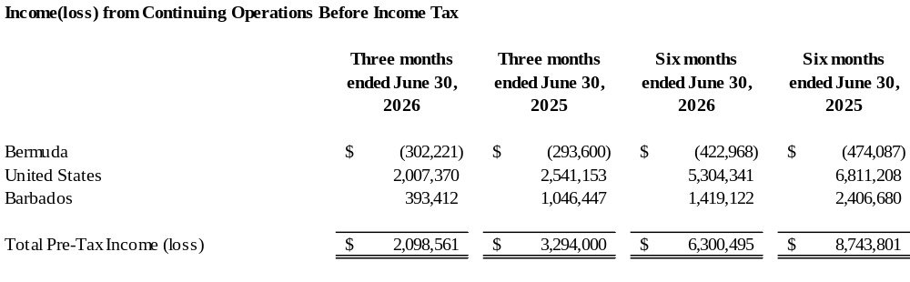
The provision for income tax expense (benefit) for the three and six months ended June 30, consisted of the following:

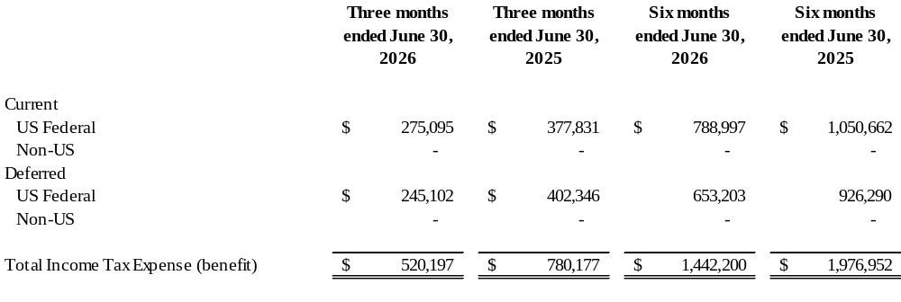
There is $1.4 million and $2.0 million provision for income taxes as of June 30, 2026 and June 30, 2025, respectively.

Effective Rate reconciliation

In December 2023, the FASB issued ASU 2023-09 which intends to enhance the transparency and decision usefulness of income tax disclosures, requiring disaggregated information about an entity’s effective tax rate reconciliation, as well as income taxes paid. The Company adopted this accounting standard prospectively, effective for the year ended December 31, 2025. The following table presents a reconciliation of expected income tax (expense) benefit for the six months ended June 30, 2026 and 2025:
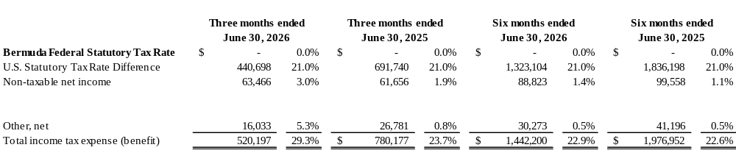

15. TAXATION (cont’d)

Net income taxes paid to national, state and local governments totaled $1.2 and $1.4 million for the six months ended June 30, 2026 and 2025, respectively as follows:

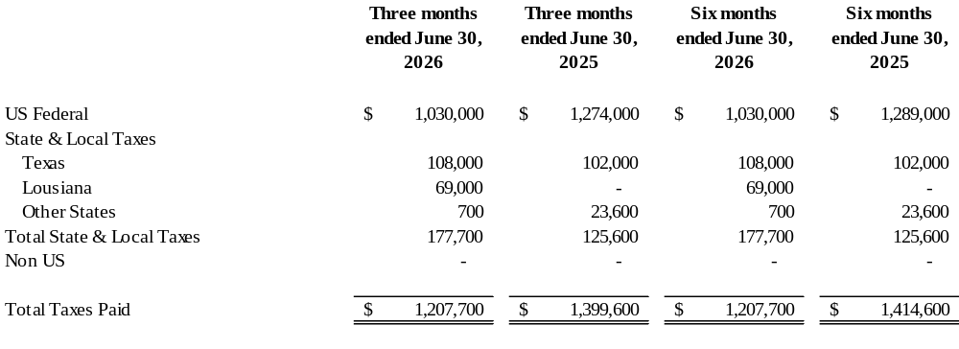

Tax effects of temporary differences that give rise to significant portions of the Company’s deferred tax assets and deferred tax liabilities at June 30, 2026 and December 31, 2025 were as follows:

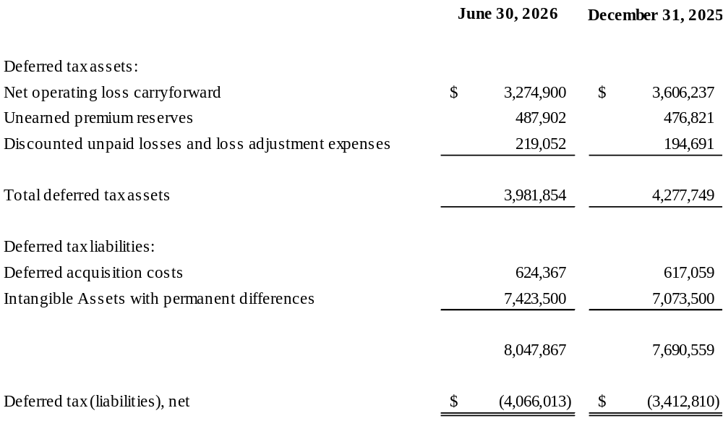

15. TAXATION (cont’d)

As of June 30, 2026, the Company had net operating loss carry forwards of $15,594,764 the expiration of which is as follows:

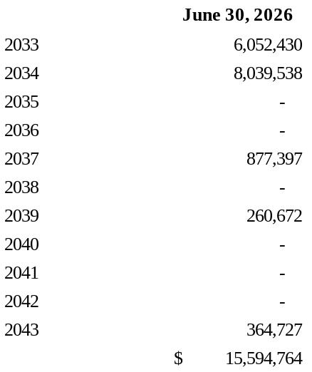

As of June 30, 2026 and December 31, 2025, the Company has no tax positions for which management believes a provision for uncertainty is necessary. The Company’s U.S. federal income tax returns for all tax years are subject to examination by the Internal Revenue Service.

16. STATUTORY REQUIREMENTS

Each of the Company's insurance companies' ability to pay dividends depends, among other things, upon their financial condition, results of operations, cash requirements, compliance with rating agency requirements, and is also subject to restrictions contained in the insurance laws and related regulations of their state of domicile and other states. Financial statements prepared in accordance with accounting practices prescribed or permitted by local insurance regulatory authorities differ in certain respects from GAAP.

The Company’s U.S. domiciled insurance companies are subject to risk-based capital standards and other minimum and capital and surplus requirements. The Company's U.S. domiciled insurance companies prepare statutory financial statements in accordance with accounting practices prescribed or permitted by the National Association of Insurance Commissioners (“NAIC”) and their respective insurance departments. Prescribed statutory accounting practices are set forth in the NAIC Accounting Practices and Procedures Manual. The Company has no permitted accounting practices on a statutory basis. OAIC is subject to NAIC risk-based capital standards and other minimum capital and surplus requirements, including the laws of Texas. Texas laws provide that without prior approval of its domiciliary commissioner, dividends to shareholders may not be paid except out of the part of surplus funds which is derived from realized net profits. Surplus funds for the purposes of this calculation are defined as the excess of assets over liabilities,
including capital stock as a liability. There are no other restrictions placed on the portion of OAIC’s profits that may be paid as ordinary dividends to its shareholder. As of June 30, 2026, OAIC had statutory capital and surplus of $23.7 million, which was in excess of any risk-based capital levels that would require corrective actions. As a Texas county mutual, OACM is not subject to NAIC risk-based capital provisions. The minimum required capital and surplus of OACM is $5 million as provided by Texas insurance law, which is the amount of capital and surplus of the entity as of June 30, 2026.

16. STATUTORY REQUIREMENTS (cont’d)

Since the Barbados Exempt Insurance Act 1983 was repealed in January 1, 2019, ORE falls under the Insurance Act. The Insurance Act does not define specific solvency standards, so Barbados still relies on the solvency criteria previously defined in the Exempt Insurance Act 1983 (the “Exempt Insurance Act”). For the purpose of compliance with the solvency criteria under the Exempt Insurance Act, assets and liabilities are calculated in accordance with US GAAP. The Barbados domiciled insurance company also must comply with the provisions of the Barbados Companies Act regulating the payment of dividends and making of distributions from contributed surplus. A company is prohibited from declaring or paying a dividend, if there are reasonable grounds for believing that: (a) the company is, or would after the payment be, unable to pay its liabilities as they become due or (b) the realizable value of the Company’s assets would thereby be less than the aggregate of its liabilities and stated capital. The excess of the ORE’s statutory assets over the aggregate of its liabilities at June 30, 2026 was $5.6 million. The minimum required solvency margin for ORE was $4.0 million.

On November 29, 2019, the Barbados government repealed the Business Companies (Economic Substance) Act, 2018-41, and replaced it with the Companies (Economic Substance) Act, 2019-43 (“the Barbados Act”). Under the Barbados Act, all resident companies/societies (other than those being grandfathered) must comply with the economic substance rules for fiscal periods commencing on or after January 1, 2020. The Barbados Act will require a resident entity which derives income from the carrying on of a relevant activity to satisfy the economic substance test in relation to that relevant activity, and will require the entity to file an economic substance declaration annually. If the Director of International Business determines that a resident entity has failed to meet the economic substance test for a fiscal period, the Director may impose a penalty. ORE is not considered a resident company under the Barbados Act, as its taxing authority is the United States of America, so the Company does not have to satisfy the economic substance test but will file an economic substance declaration each year. In 2026, ORE will file the declaration related to 2025 and will file the 2026 declaration in 2027.

AOG must comply with the provisions of the Bermuda Companies Act regulating the payment of dividends and making of distributions from contributed surplus. A company is prohibited from declaring or paying a dividend, or making a distribution out of contributed surplus, if there are reasonable grounds for believing that: (a) the company is, or would after the payment, be unable to pay its liabilities as they become due or (b) the realizable value of the company’s assets would thereby be less than its liabilities. The Board of Directors of AOG will evaluate any dividends in accordance with this test at the time such dividends are declared.

17. SUBSEQUENT EVENTS
Subsequent events have been evaluated through September 30, 2026, which is the date the financial statements were issued.

